--- **EZTRIM** ---

OPERATORS MANUAL

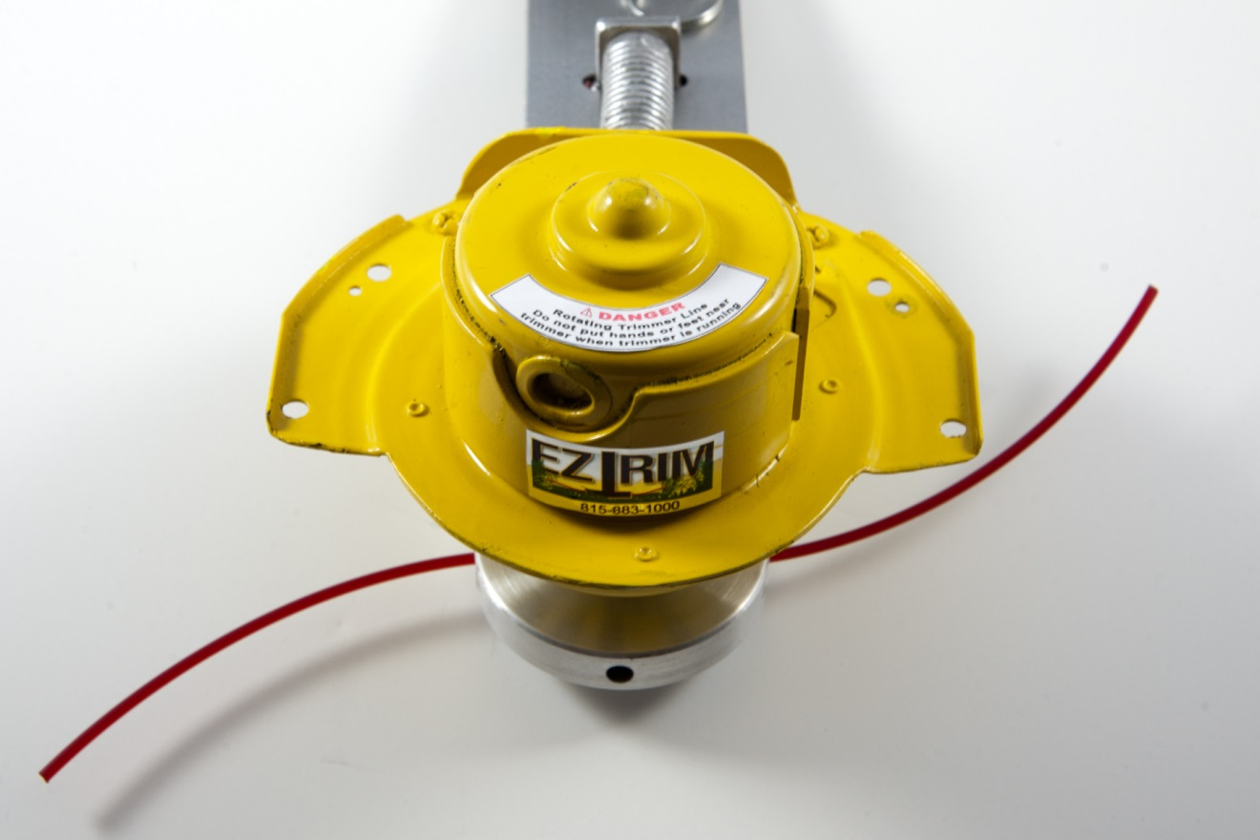

**WARRANTY**

**LIMITED WARRANTY FOR EZTRIM TRACTOR MOUNTED GRASS TRIMMER**

**EZTRIM** Warrants to the original owner that each new part that was purchased from our company is free from defects in workmanship and materials. **EZTRIM** agrees to repair or replace under this warranty any defective part for 12 consecutive months from the original dated sales slip. (proof of purchase) This original sales receipt must accompany any returns or claims. This warranty is excluded from any other non-residential use such as commercial use.

THIS LIMITED WARRANTY DOES NOT COVER THE FOLLOWING AND IS NOT TRANSFERABLE

Freight cost from customer to manufacturer. Improper installation or incorrect voltage.

Scratches or imperfections that do not Expendable items that wear because of

interfere with the operation of this system. use.

Damages caused by rain, excess humidity You must call 815-883-1000 for a return

corrosive environments, or contaminants. number before sending back.

Give us a call @ **EZTRIM**  815-883-1000 if you have any problems and we will try to help you.

## INSTALLATIONS / INSTRUCTIONS

## TOOLS NEEDED

TAPE RULE

12” STRAIGHT EDGE

TEMPLATE

MASKING TAPE

MARKER

3/16” DRILL BIT, 3/8” DRILL BIT

25/64” DRILL BIT

BATTERY OR ELECTRIC POWERD ½” DRIL

(2) ADJUSTABLE WRENCHS

**INSTRUCTIONS**

1.- EZTRIM unit mounts directly to the top of your lawn mower deck opposite side of the discharge chute.

2.- Use tape rule to measure the center of your mower deck. (As a check the center of your mower should line up with the center pulley guard in figure #1.)Use a straight edge and mark a line as shown in figure #1.

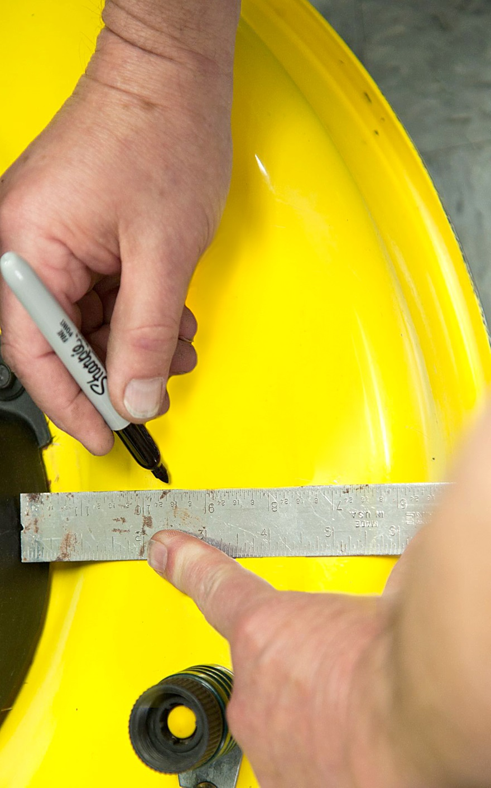

3.- Cut and fold the template from the back page # 8 making sure you cut the 2 arrows out, as this will enable you to line up the template properly. See figure # 2 on the next page.

Align the center line of the template to the marked center line of the deck, using the notches or arrows that were cut in the template. The folded tab should flush and square with the front of

your mower deck.

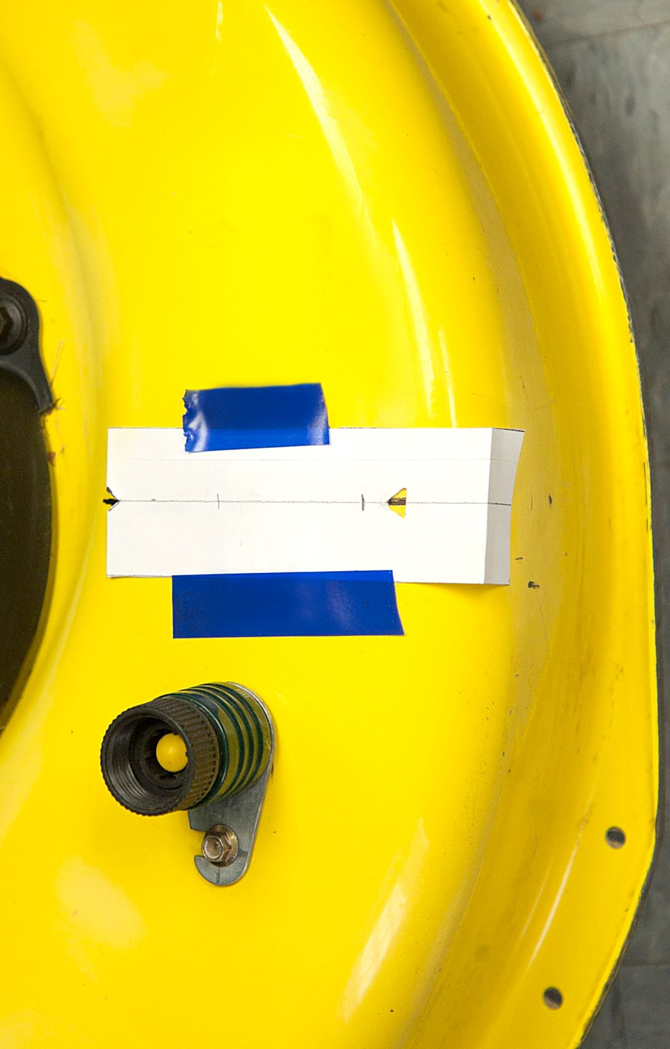

Once aligned with the center line of the mower tape the template in place shown figure #2 above.

You are now ready to drill the (2) 3/16" pilot holes thru the deck. Make sure you use the markings on the template shown in figure # 3 below.

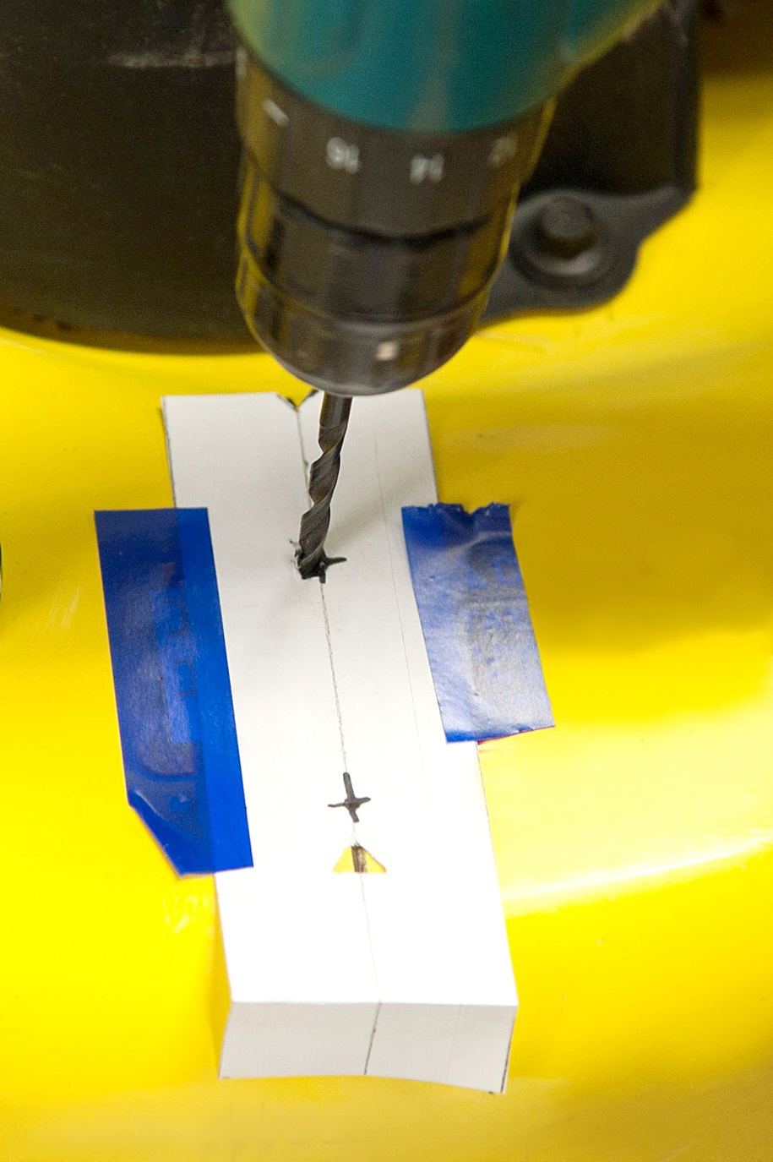

Once both pilot holes are drilled remove the taped template and drill the holes out to 3/8” in figure # 4 below.

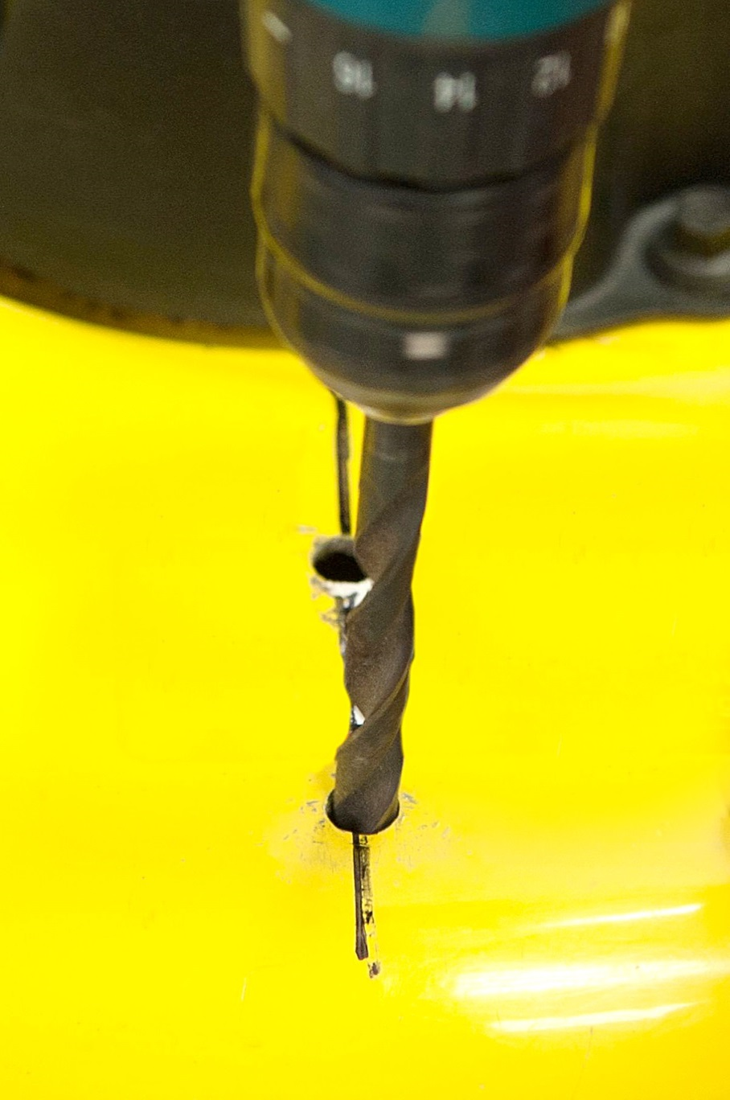

**YOU ARE NOW READY TO INSTAL YOUR EZTRIM UNIT**

Take your **EZTRIM** unit and mount it to the top of your deck as shown in figure# 5 below.

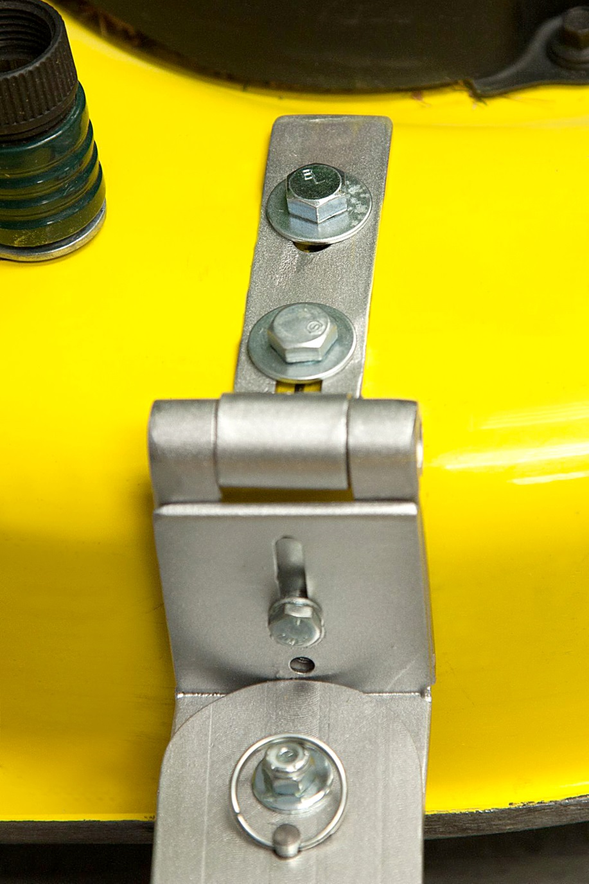

Place the (2) flat washers on each 3/8” x 1” bolts provided, slip them through the bracket and then through the deck as shown in figure # 5 above. **Make sure the mower is not running**. While holding the unit in place reach under the deck install the lock washers and nuts provided. As you snug the nuts make sure the unit is square with the front of your deck. Once square you can tighten the mounting bolts, again make sure the bracket is square with the front edge of the mower.

**MAKE SURE THE BOLTS ARE GOOD AND TIGHT**

After the unit is mounted you may need to adjust the height of the unit. (check 1st the proper cutting height or cutting string should be set 3/4”~ 1 ¼”” higher than the bottom of your mower deck.) If not you can loosen the height adjustment bolt and raise or lower the unit to the proper height. Once to the proper height, retighten the adjustment bolt. **MAKE SURE IT IS TIGHT!!**

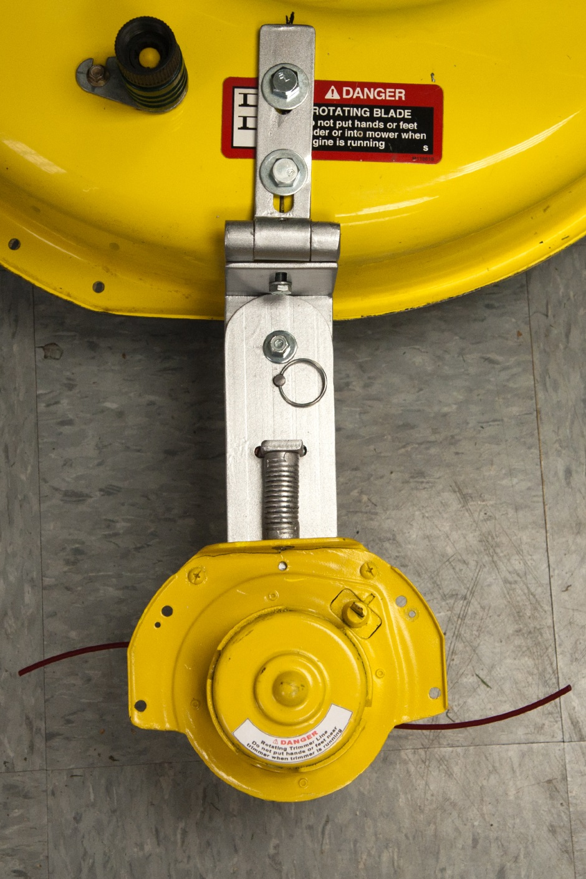

# NOW IT’S TIME TO CONNECT THE PREASSEMBLED WIRE HARNES

One end of the wire harness has been installed to the trimmer motor this end is ready to go so the next thing is to locate your battery. Loosen the negative side of the battery terminal first. ( the negative side has a black wire attached to the terminal do not remove that wire), just take the black wire from the new wire harness and slip that terminal on to the loosened screw and retighten so the black wires are tight. Next is to loosen the screw on the positive side of the battery. (the positive side has red wire attached do not remove that wire) just take the red wire from the new wire harness and slip that terminal on to the loosened screw and retighten so the red wires are tight. Your wire harness is now ready for the next step.

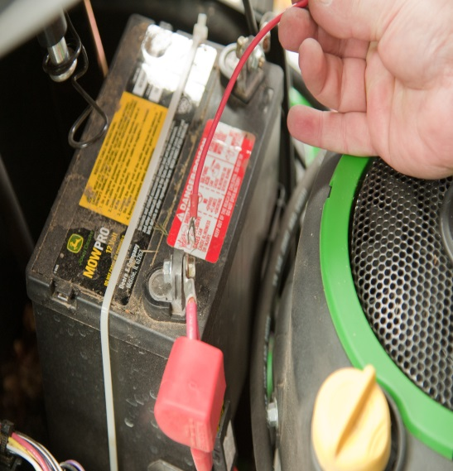 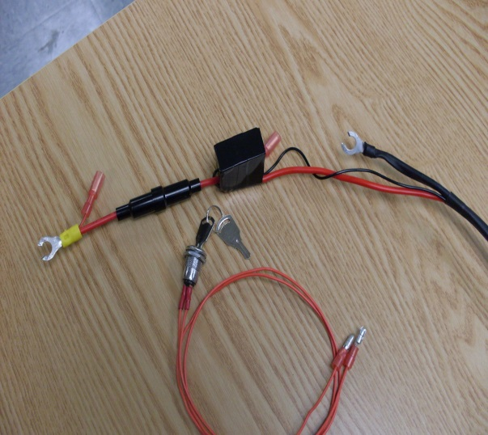

# The next step is to install your keyed switch for your safety

This switch should be installed within 11” of your battery preferably on the dash where it will be convenient to use. You will need a 25/64”drill bit for this step of the installation. Now it is time to look for a convenient spot on your dash that is less than 11” from the battery. Once you find a good location, Check to make sure that part of the dash is clear on both sides so when you drill through the dash you will not hit anything while drilling a 25/64” hole. Now that the hole has been drilled remove the nut from the switch then push both red wires through the hole. Restring the nut over the wire on the back side of the dash up to the threaded portion of the switch tighten that nut onto the switch so it is good and tight. This nut must be tight enough so the switch does not turn during operation. Now that your switch was installed you need to connect both red wires. At the end of these wires there is preassembled push in terminals, you must push in these terminals into the female terminals that are on the wire harness. There is no special way to install them. (If the motor starts while installing the red wires then stop and turn the switch so the switch is in the off position.) Now finish installing the red wires.)

# Now you are ready to start trimming move your tractor to an open space in your lawn that has already been cut, get off the tractor and visually look at the string height in comparison to the previously cut grass if the string touches the top of the grass you should raise your mower deck up one notch. You are ready to try turn the key on and make sure the trimming head is not too low, it should not be cutting into the previously cut grass. If it is raise your mowers deck one more notch. Set your forward speed as slow as the tractor will go and you now are ready to start trimming. Turn the key on and start. Once you get the hang of driving around obstacles you can increase the forward speed a little bit. It is a bit harder than you think to stay the correct distance away from what you are trimming. Too close and you will wear out the strings quickly. Too far and you will leave some standing grass.

# DRILL TEMPLATE